2022

**February 28**





**TRANSACTION SCREENS AND REPORTS DESIGN SPECIFICATIONS**

**Commission Adjustment**

**Design Approval Sheet**

|  |  |
| --- | --- |
|  |  |
| **________________________________________**  **CYRENE INOY**  Systems Analyst/Programmer  Asian Business Solutions, Incorporated  **________________________________________**  **ANGELA L. ARAGON**  Senior Technical Manager  Asian Business Solutions, Incorporated |  |
| **________________________________________**  **CARMENCITA L. ARAGON**  President  Asian Business Solutions, Incorporated |  |
|  |  |
|  |  |

DOCUMENT INFORMATION AND REVISION HISTORY

|  |  |  |  |  |
| --- | --- | --- | --- | --- |
| Document Title | | ASIAN BUSINESS SOLUTIONS, INC.  INTEGRATED INSURANCE BROKERAGE SYSTEM v5  TRANSACTION SCREENS AND REPORTS DESIGN SPECIFICATIONS  Commission Adjustment | | |
| **Author** | | Cyrene Inoy | | |
|  | | | | |
| **Revision History** | | | | |
| **Document Version No.** | **Date** | **Author** | **Summary of Changes** | **Reviewed By** |
| 1.0 | 28-Feb-22 | Cyrene Inoy | Initial Release |  |

Matthew Edward N. Manlangit

BSCS -IV

Documentation OJT

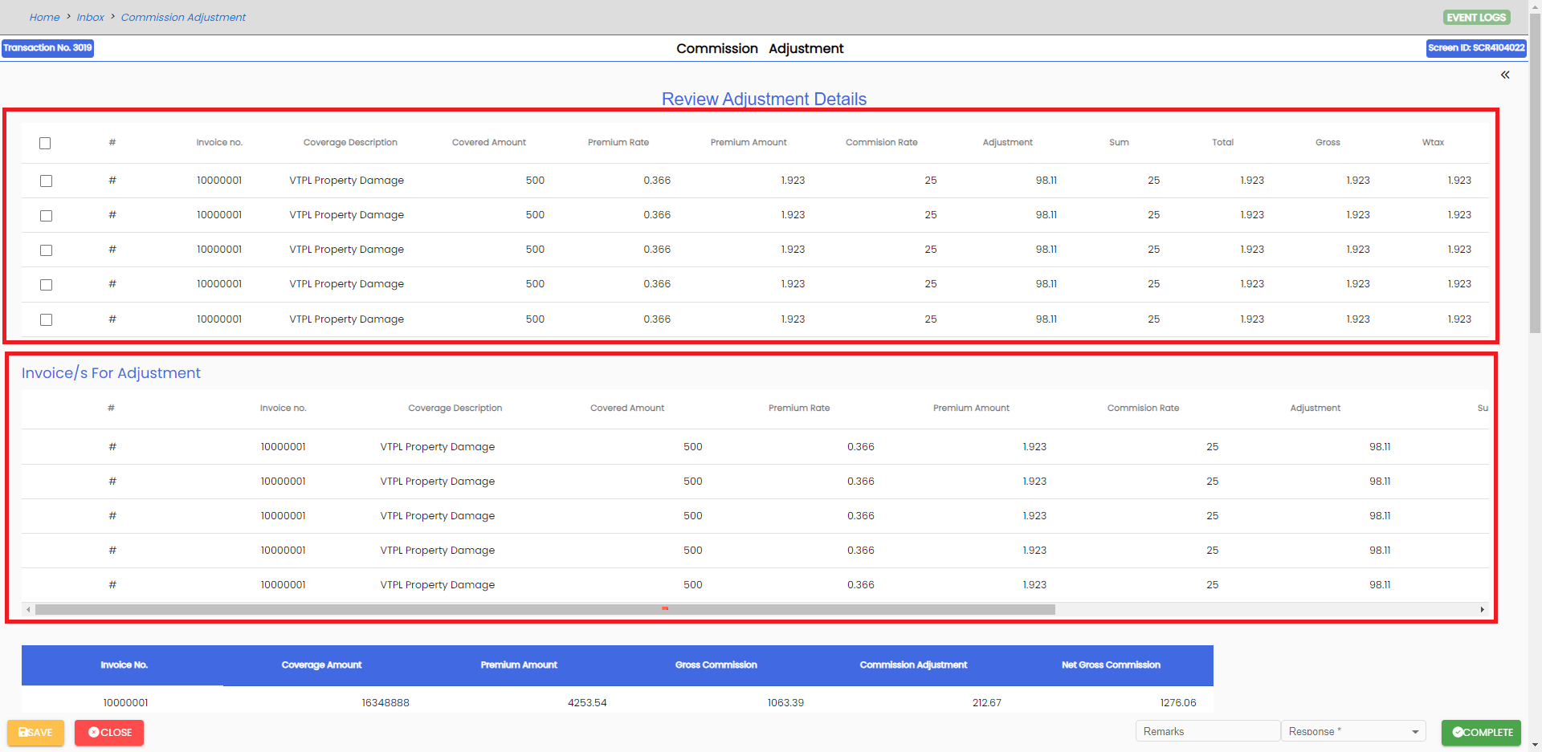1st and 2nd review screens The reviewer screen is a one pager screen where the end-user may review details of the adjustment. I followed Ma’am Angela’s Instruction to put the checkbox that pops up a review table but I was unable to find on how to make Javascript work in angular for this. The reviewer screen is a one pager screen where the end-user may review details of the adjustment. The reviewer screen is a one pager screen where the end-user may review details of the adjustment. The reviewer screen is a one pager screen where the end-user may review details of the adjustment

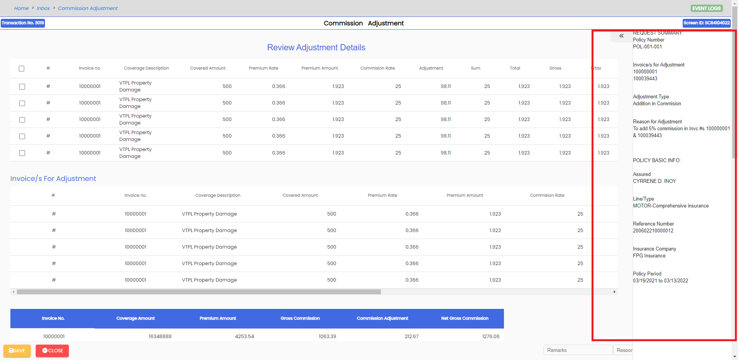Sidenav

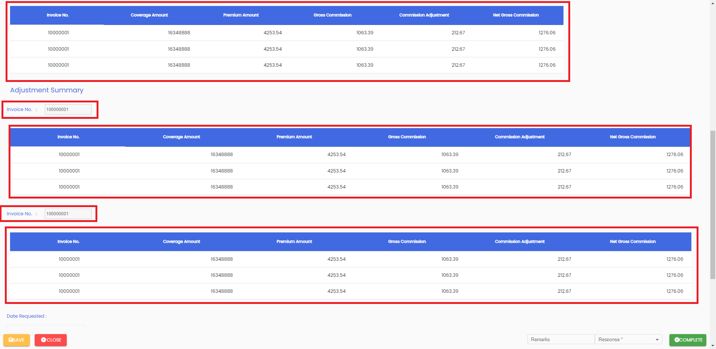The approver ensures that the adjusted invoice is correct thus, the approver may modify the invoice/s for adjustment so the encoder may revise adjustment amounts based on corrected invoice/s. The Input is disabled as instructed by Ma’am Cy.

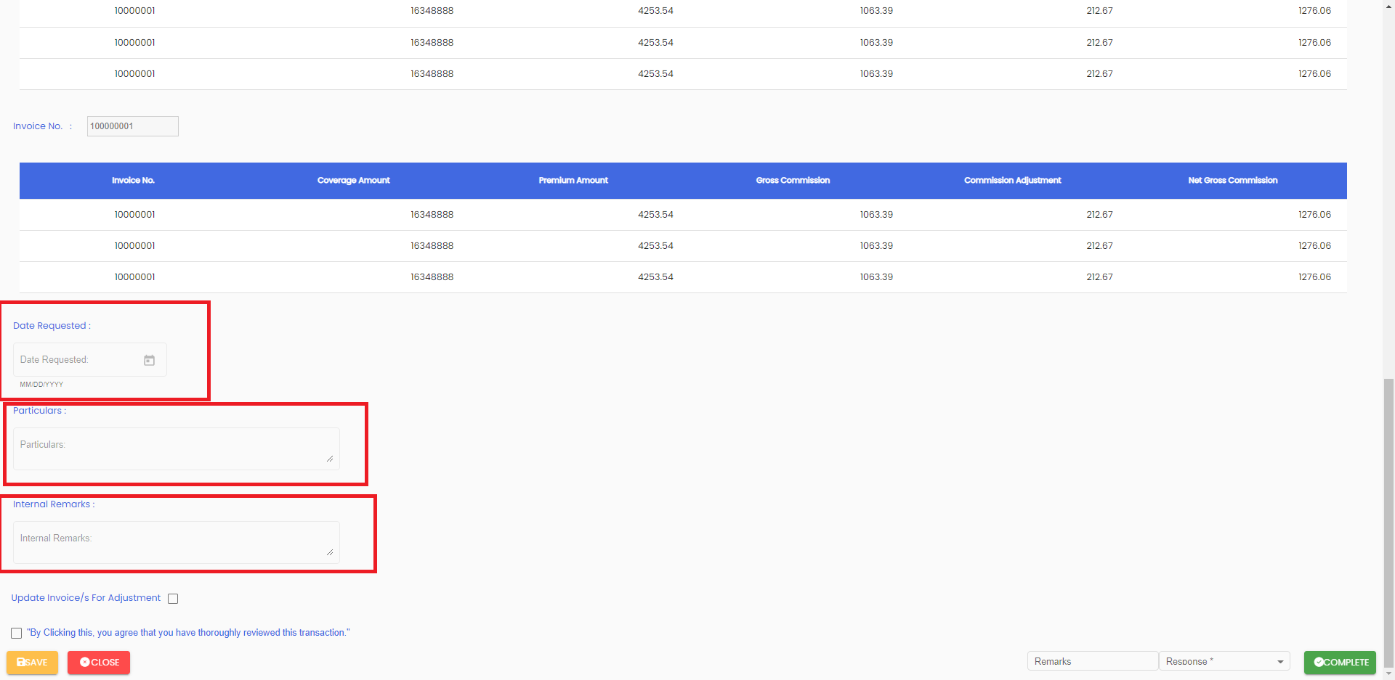The Datepicker is disabaled as well as the Particulars and Internal Remarks Input as Instructed by Ma’am Cy

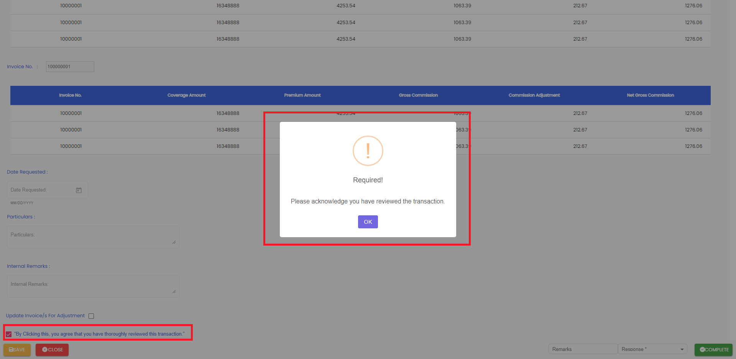shows the confirmation and system message on complete of the ‘Approve Adjustment’ response.

The Sweet Alert that the Save Close and Complete that is shown are the same I based it on the screen standard

